NOTE TO TEACHERS:

Do not give the students the article on the actual flight of the parachute
until after they have completed their inquiry booklet.

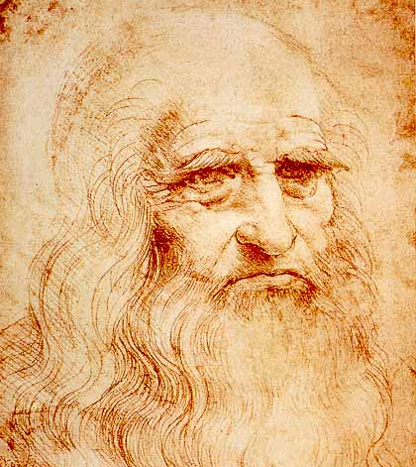

L e o n a r d o d a V i n c i

Leonardo da Vinci was a Florentine artist, one of the great masters of the High Renaissance who was also celebrated as a painter, sculptor, architect, engineer, and scientist. His profound love of knowledge and research was the keynote of both his artistic and scientific endeavors. His innovations in the field of painting influenced the course of Italian art for more than a century after his death, and his scientific studies—particularly in the fields of anatomy, optics, hydraulics and flight—anticipated many of the developments of modern science.

Leonardo was born on April 15, 1452, in Vinci, Italy, just outside Florence. As a boy he had access to scholarly texts and was exposed to Vinci's longstanding painting tradition. When he was 15 his father apprenticed him to the renowned workshop of Andrea del Verrochio in Florence. Even as an apprentice, Leonardo demonstrated a talent that was so great that Verrochio allegedly resolved never to paint again.

From 1485 to 1490, Leonardo produced studies on many subjects, including nature, flying machines, geometry, mechanics, municipal construction, canals and architecture. Leonardo's interests were so broad that he usually failed to finish what he started. This resulted in completing only six works of art in 17 years, including The Last Supper and The Virgin on the Rocks.

Between 1490 and 1495 Leonardo developed a habit of recording his studies in meticulously illustrated notebooks. His work covered four main themes: painting, architecture, the elements of mechanics, and human anatomy. These studies and sketches were collected into various codices and manuscripts most of which were written in mirror script. These documents are today high sought after by museums as well as individual collectors (Bill Gates recently paid $30 million for the Codex Leicester).

In 1503, Leonardo began work on one of the most recognized paintings of all time Mona Lisa. It is not known exactly who Mona Lisa was, but Leonardo’s painting has made her face famous. The painting hangs today in the Louvre Museum in Paris, France. From 1514 to 1516, Leonardo worked in Rome, maintaining a workshop and undertaking a variety of projects for the Pope Leo X. Toward the end of his career Leonardo went to France to work for King Francis I. Leonardo died on May 2, 1519 in Cloux, France.
Leonardo da Vinci Sketches

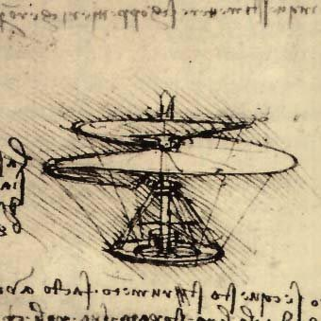
Helicopter Design

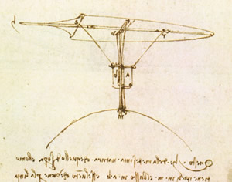

Glider Design
The Da Vinci Parachute

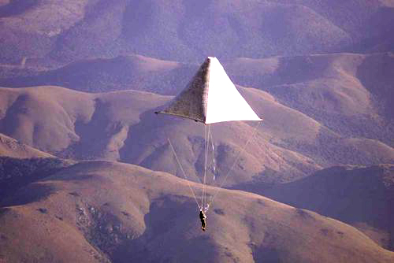

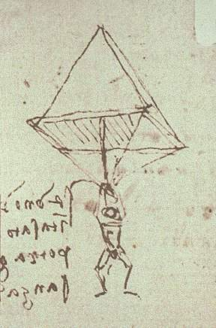
Leonardo Da Vinci was proved right on Monday, June 26, 2000, some 500 years after he sketched the design for the world's first known parachute. A British man, Adrian Nicholas, dropped from a hot air balloon 3,000 meters (10,000 feet) above the ground, after ignoring expert advice that the canvas and wood contraption would not fly. Attempts to fully test the parachute in the UK earlier this year failed due problems of wind and safety near populated areas - it weighs a hefty 85 kilograms (187 pounds). But in the wide open spaces of Mpumalanga, South Africa, Mr. Nicholas safely floated down, saying the ride was smoother than with modern parachutes. Heathcliff O'Malley, who photographed the drop from a helicopter, told BBC News Online: "It was amazing, really beautiful. But none of us knew if it would fold up and Adrian would plummet to Earth."
He added: "It works, and everyone thought it wouldn't."
Mr Nicholas cut himself free when he reached 600m (2,000 ft) and deployed a second modern parachute. This ensured the heavy device did not crash down on top of him on landing. The parachute's great weight was due to the use of materials that would have been available in medieval Milan, rather than modern fabrics. Period tools were also used.
The original design was sketched by Da Vinci in a notebook in 1483. An accompanying note read: "If a man is provided with a length of gummed linen cloth with a length of 12 yards on each side and 12 yards high, he can jump from any great height whatsoever without injury." Mr. Nicholas said he thought Da Vinci would have been pleased, even if the vindication of his idea came five centuries late.

http://www.angelfire.com/electronic/awakening101/davinci-chute.html

