Leonardo da Vinci’s Parachute
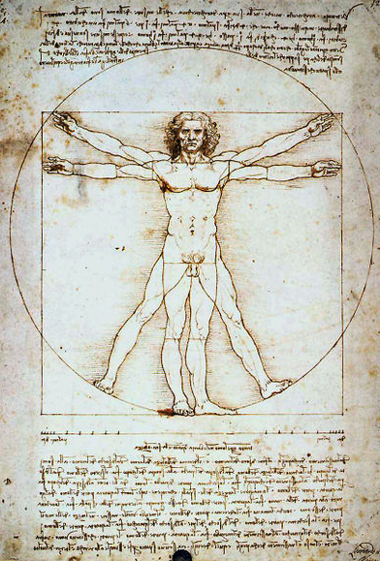
An Experiment of
Inquiry & Discovery

Students Name:

About the da Vinci Parachute
More than 500 years ago Leonardo da Vinci sketched the design for the world's first known parachute. The original design was sketched by Da Vinci in a notebook in 1483 (see on the cover). An accompanying note read: “If a man is provided with a length of gummed linen cloth with a length of
12 yards on each side and 12 yards high, he can jump from any great height whatsoever without injury.” Until recently it was unknown if da Vinci’s parachute would work. If the parachute was made using materials from da Vinci’s life time, the parachute's would be very heavy (almost 200 pounds).

Use the space below to sketch the model of Leonardo da Vinci’s parachute:

Use the space below to make you prediction about the performance of the
da Vinci parachute:
Important: Do not just write one word answers, elaborate with full sentences and paragraphs that support your predictions.
Will it work? (include you theory on why it will or will not work)

If it does work, will it work better or worse that the modern parachute?

If a full-scale version of the da Vinci parachute was made using materials used during da Vinci’s time period, would it work? (include you theory on why it will or will not work)

Use the space below to record the experimental flights of the parachutes:
Important: Be descriptive.
Modern Parachute Experiment 1:

Modern Parachute Experiment 2:

Modern Parachute Experiment 3:

Da Vinvi Parachute Experiment 1:

Da Vinvi Parachute Experiment 2:

Da Vinvi Parachute Experiment 3:

