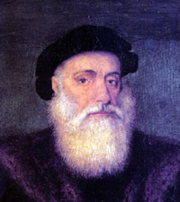

V A S C O D A G A M A

Vasco da Gama was a Portuguese explorer who discovered an ocean route from Portugal to the East. Da Gama was born to a noble family in Sines, Portugal. Da Gama's father Estavao was also an explorer. He was to have made the sea voyage from Portugal to India that eventually made his son famous, but the elder da Gama died before completing the journey.

Vasco da Gama sailed from Lisbon, Portugal, on July 8, 1497, heading to the East. At the time, many people thought that da Gama's trip would be impossible because it was assumed that the Indian Ocean was not connected to any other seas. Da Gama's patron was King Manuel I of Portugal. Da Gama rounded Africa's Cape of Good Hope on November 22, and continued on to India (route). After many stops in Africa, and problems with Muslim traders who did not want interference in their profitable trade routes, da Gama reached Calicut, India on May 20, 1498.

At first, da Gama and his trading were well-received, but this did not last for long. Da Gama left India on August 29, 1498, after he was told to pay a large tax and leave all of his trading goods. When he left, da Gama took his goods with him, together with some Indian hostages. Da Gama returned to Lisbon, Portugal, in September, 1499. Along the way many crew members died from scurvy (a disease caused by a lack of Vitamin C). Upon his return, da Gama was treated as a hero and was rewarded by King Manuel I of Portugal.

King Manuel I later sent da Gama, now an Admiral, on another expedition to India (1502-1503). On this second trip, da Gama took 20 armed ships (anticipating problems from Muslim traders). On this voyage, da Gama killed hundreds of Muslims, often brutally, in order to demonstrate his power. After King Manuel's death, King John III sent da Gama to India as a Portuguese viceroy (the King's representative in India). Vasco da Gama died of an illness in India on December 24, 1524; his remains were returned to Portugal for burial.

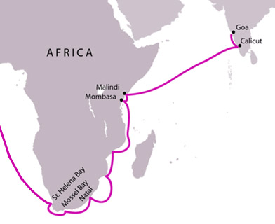

Da Gama's route around Africa to India

