Don't always center your subject in the frame
A handy rule to follow that will help you to compose a quality photo every time is the rule of thirds. In your mind, divide the image into thirds, both horizontally and vertically.
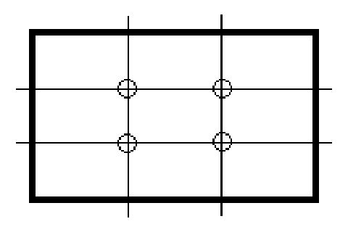
Place the most important part of your picture--the center of interest--at one of the four places where the imaginary lines cross. A person who is the subject of interest should look or appear to be moving toward the center of the picture. When taking a picture with a horizon, place the horizon line on one of the horizontal thirds, depending on the emphasis you want in the picture.
When taking photos of people, don't chop them off at the knees or ankles. Include the entire body or shoot your subject from the waist up.
Remember: Place the subject about one third of the way into the frame from the left or right and about one third of the way into the frame from the top or bottom.

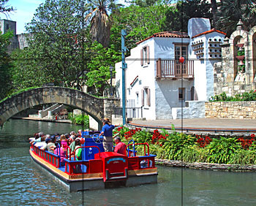

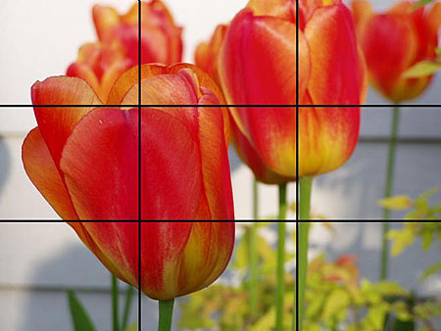

Perspective
If you look along a straight road, the parallel sides of the road appear meet at a point in the distance. This point is called the vanishing point and has been used to add realism to art since the 1400's in Florence, Italy.
Suppose you want to draw a railroad track that vanishes into the distance. The rays from the points a given distance from the eye along the lines of the tracks are projected to the eye. The angle formed by these rays decreases with increasing distance from the eye. The picture below shows an overhead view of an observer (camera or eye) looking down the track.
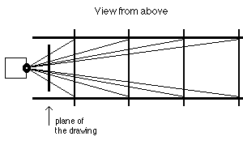
The next picture shows a side view. The observer's eye or camera is above the ground.
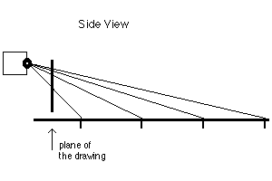
Draw these pictures on graph paper and try to figure out where the points would fall on the plane of the drawing. Can you draw the railroad track?
Solution
To draw in perspective, draw a horizon line and draw a vanishing point anywhere on the horizon. Lines which are parallel in real life are drawn to intersect at the vanishing point.
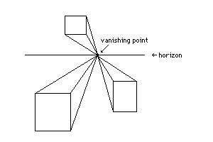
Distant figures appear smaller but have the same shape and proportions as they would close up. In geometry, we would say that the figures are similar.
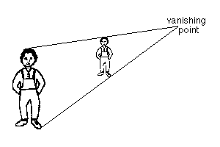
The picture below shows a long hallway with a window in the left wall. The window is a trapezoid. Can you use your knowledge of geometry to draw another window further down the hallway? An entire row of windows? To start with the simplest problem, assume the window tops are all at the same height in the hallway and assume the window bottoms are all at the same level in the hallway.
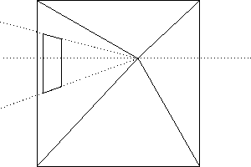
Solution
Early Renaissance Painting
Linear perspective was a system set up to help create the illusion of three-dimensional space in a two-dimensional format. It originated in the Near East where some nomads noticed that a small pinhole carried an upside-down picture of the outside, in a dark tent, in the middle of the day. This later was used by Renaissance artists in the form of a camera obscura (Latin for black box). Artists would build small dark booths and move them to wherever they wanted to paint, then poke a pinhole in the wall, and copy the scene that was projected upside-down on the wall behind them. The system is based on the idea of a constant horizon line (eye level) where a vanishing point is located. One can anticipate the convergence of parallel lines at the vanishing point.

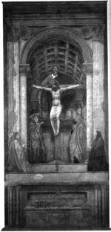
Holy Trinity
Italian Renaissance
by Masaccio
1425
fresco

