L E S S O N P L A N

SUBJECT: Television/Film

GRADE LEVEL: 8th Grade (± 2 Grades)

DURATION OF LESSON: Three 40 minute periods

LESSON TITLE: Aesthetics and perspective on Screen

NJ CORE CURRICULUM CONTENT STANDARDS: 1.1; 1.2
1.1 All students will acquire knowledge and skills that increase aesthetic awareness
1.2 All will refine perceptual, physical and technical skills through creating visual arts.
1.4 All students will demonstrate knowledge of the process of critique.

FOCUS DISCUSSION:
• Discussion on the aesthetics/perspective in the past in the renaissance and how it’s used on a screen today. Balance/ colors/ light/ shot composition/ perspective, depth of field/ rule of thirds.
• Discussion on what the director is trying to convey with the various shots chosen.
• Discussion on what it takes to visually get your message across to the viewer by shot composition.

OBJECTIVES: After completion of the lesson SWBAT frame shots correctly, read and comprehend an image. The will being to understand the significance of aesthetics rule of thirds/ perspective, colors, shapes depths of field, everything that composes a picture. SWDTAT compose shots and tell a story through images. (1.1, 1.2, 1.4)

PRE-REQUISITE KNOWLEDGE: Aesthetics/ Basic knowledge of shot composition/ lighting and balance in a picture.

MATERIALS:
• Hand-out on the rule of thirds/perspective (one per student)
• Pictures/ paintings of the renaissance period and today
• Clips of shows today
• Still Camera

DESCRIPTION OF LESSON:
Teacher Will:
• Lead the students through the discussions of the theory of aesthetics
• Explain the rule of thirds
• Lead the students through the discussion on the aesthetics on screen (practical use of aesthetics).

Students Will:
• Participate in a discussion about the aesthetics on a screen and in art work.
• Students will discuss the emotions they receive from viewing different clips from shows today and pictures.
• Students will shoot still pictures and or moving images demonstrating depth of field/perspective/ and rule of thirds.
• They will observe record and discuss in class what they were trying to obtain with their footage/pictures.
• read the hand outs given to them. A written summary for what they were trying to convey with their footage/ pictures. Take what was said in class and write about what they could have done differently.

ASSESSMENT:
The teacher will collect all footage/ pictures and assess them on the effort and thought put into the project, their knowledge of perspective as well as the participation and input in class discussions.
Students must also pick a piece of art work and analyze based on what they learnt during the lesson.

SELF REFLECTION OF LESSON:

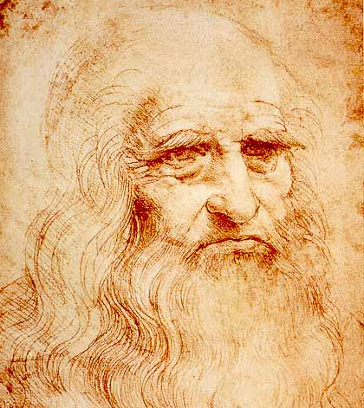

L e o n a r d o d a V i n c i

Leonardo da Vinci was a Florentine artist, one of the great masters of the High Renaissance who was also celebrated as a painter, sculptor, architect, engineer, and scientist. His profound love of knowledge and research was the keynote of both his artistic and scientific endeavors. His innovations in the field of painting influenced the course of Italian art for more than a century after his death, and his scientific studies—particularly in the fields of anatomy, optics, hydraulics and flight—anticipated many of the developments of modern science.

Leonardo was born on April 15, 1452, in Vinci, Italy, just outside Florence. As a boy he had access to scholarly texts and was exposed to Vinci's longstanding painting tradition. When he was 15 his father apprenticed him to the renowned workshop of Andrea del Verrochio in Florence. Even as an apprentice, Leonardo demonstrated a talent that was so great that Verrochio allegedly resolved never to paint again.

From 1485 to 1490, Leonardo produced studies on many subjects, including nature, flying machines, geometry, mechanics, municipal construction, canals and architecture. Leonardo's interests were so broad that he usually failed to finish what he started. This resulted in completing only six works of art in 17 years, including The Last Supper and The Virgin on the Rocks.

Between 1490 and 1495 Leonardo developed a habit of recording his studies in meticulously illustrated notebooks. His work covered four main themes: painting, architecture, the elements of mechanics, and human anatomy. These studies and sketches were collected into various codices and manuscripts most of which were written in mirror script. These documents are today high sought after by museums as well as individual collectors (Bill Gates recently paid $30 million for the Codex Leicester).

In 1503, Leonardo began work on one of the most recognized paintings of all time Mona Lisa. It is not known exactly who Mona Lisa was, but Leonardo’s painting has made her face famous. The painting hangs today in the Louvre Museum in Paris, France. From 1514 to 1516, Leonardo worked in Rome, maintaining a workshop and undertaking a variety of projects for the Pope Leo X. Toward the end of his career Leonardo went to France to work for King Francis I. Leonardo died on May 2, 1519 in Cloux, France.

the Renaissance

The word renaissance means a rebirth of intellectual and artistic achievement and vigor and the revival of the human spirit as it was in the classical times of Greece and Rome. It is commonly used to refer to the transitional movement in Europe between medieval and modern times. The Renaissance period began in the 14th century in Italy, and spread throughout Europe, lasting into the 17th century. The Renaissance period is marked by a humanistic revival of classical influence expressed in a flowering of the arts, architecture and literature and by the beginnings of modern science.

